Bakbase

IntelliJ

Run Configuration

Portal server-

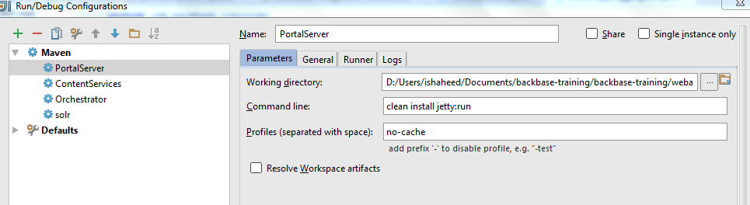

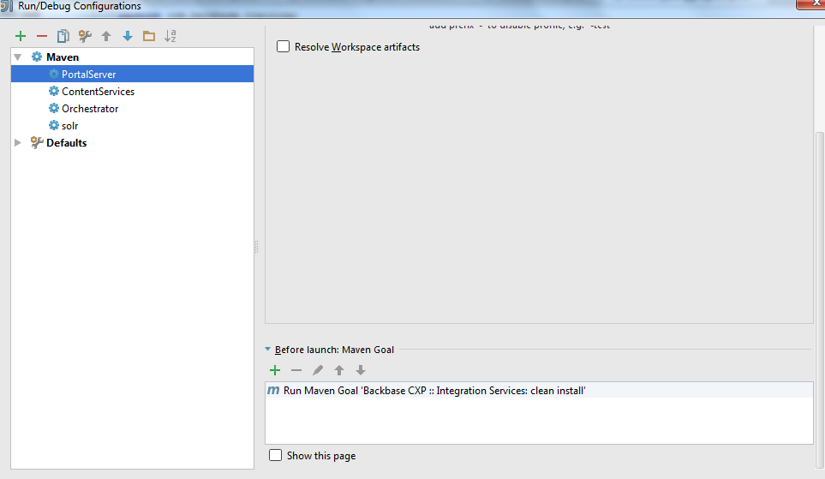

Orchestrator-

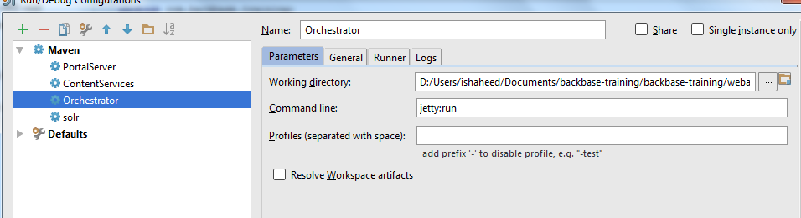

Content service

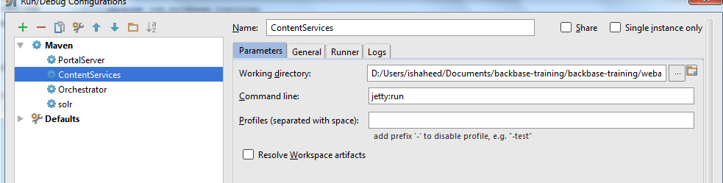

Solr-

